**DAILY ONLINE ACTIVITIES SUMMARY**

|  |  |  |  |  |  |  |  |  |
| --- | --- | --- | --- | --- | --- | --- | --- | --- |
| **Date:** | **03/06/2020** | | | | | **Name:** | **Pratibha Shetti** | |
| **Sem & Sec** | **IV sem & B section** | | | | | **USN:** | **4AL18CS062** | |
| **Online Test Summary** | | | | | | | | |
| **Subject** | | **Object Oriented Concepts** | | | | | | |
| **Max. Marks** | | **30** | | **Score** | | | **14** | |
| **Certification Course Summary** | | | | | | | | |
| **Course** | **Java Learning** | | | | | | | |
| **Certificate Provider** | | | **Greatlearning academy** | | **Duration** | | | **2.5 hours** |
| **Coding Challenges** | | | | | | | | |
| **Problem Statement1:** Write a Java program to find Last Digit of a^b (a to the power b) for Large Numbers.  **Problem Statement2:** Write a code segment in java to swap two numbers using call by object reference.  **Problem Statement3:**Write a function that takes a two-digit number and determines if it's the largest of two possible digit swaps. | | | | | | | | |
| **Status: Executed** | | | | | | | | |
| **Uploaded the report in Github** | | | | | **YES** | | | |
| **If yes Repository name** | | | | | <https://github.com/pratibhashetty-123/Lockdown-coding-java>  <https://github.com/pratibhashetty-123/Lockdown-coding-for-C> | | | |
| **Uploaded the report in slack** | | | | | **YES** | | | |

Online Test Summary: 18CS45 test was scheduled from 9:30 am t0 10:00am .The portion for the IA was 2nd and 3rd module there were 30 questions and the time assigned was 45 minutes the questions were to predict the output of the given program.

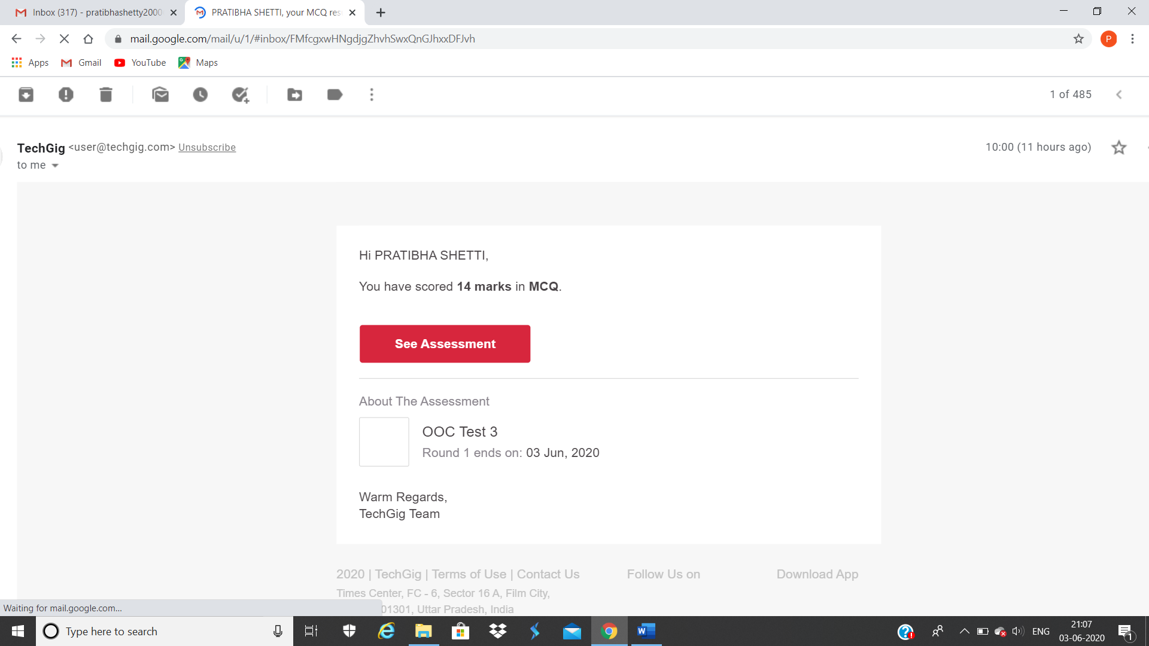

The above snap shot is the completion of the test and the marks allotted.

Online Certification Course Summary: In today’s session I have learnt about java coding and I have finished all sections today.

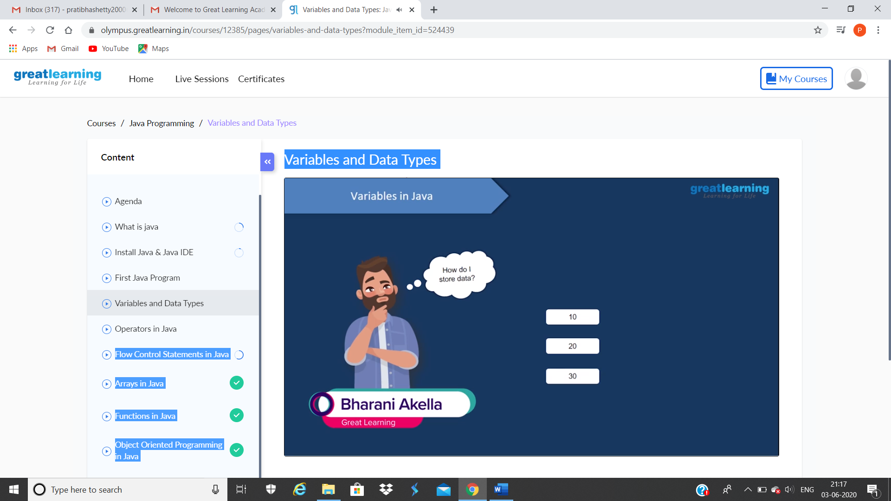

These are the snap shots of today’s sessions.

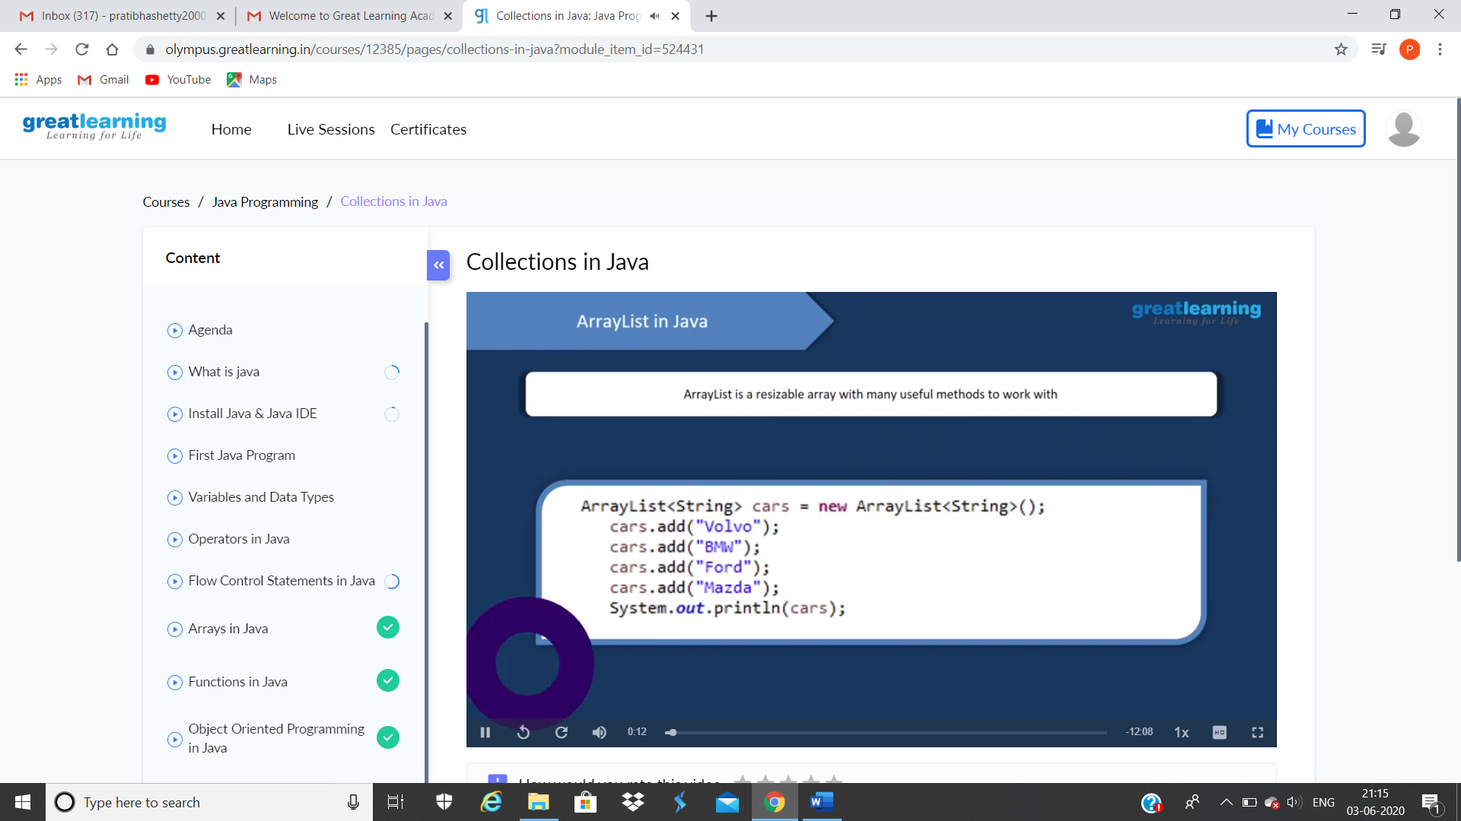

This is the snap shot of today section

Online Coding Summary: **Today I had received one program from prof. Shilpa CSE Dept. the other from Prof. Reena Lobo CSE Dept. and Prof.Vasudev CSE Dept. The program is mentioned above in the coding challenges(pg.01). I have also uploaded it to my Github repository.**

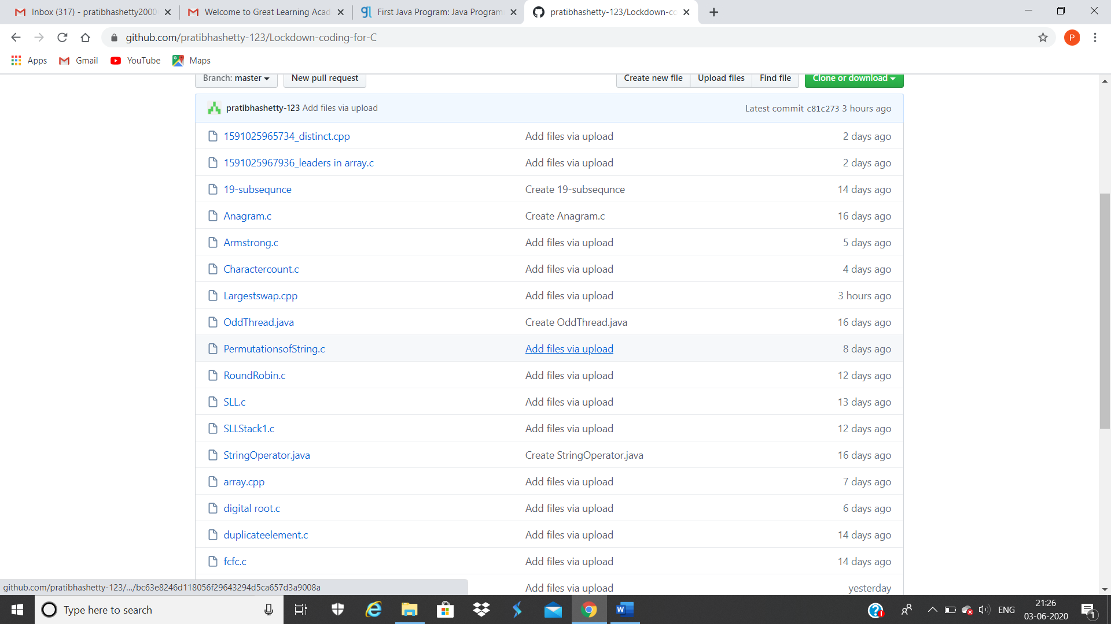

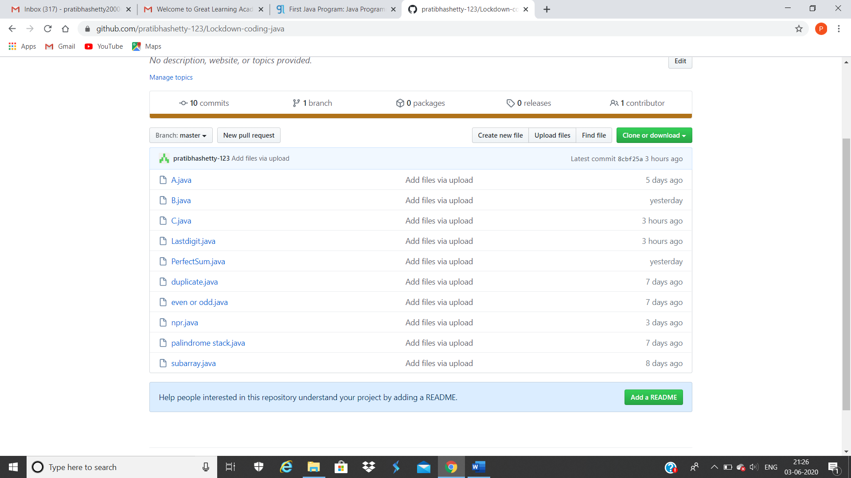**This are the snap shots of my Github repository** were I have uploaded the code. File name is C.java, Lastdigit.java and Largestswap.cpp